**BF[1] – Multiple Comparisons Key**

**Type in your score here 🡪 ____ out of 25 points possible**

1. (5 points) Ponder/Reflect Exercise – Reflect on what you have learned from this portion of the class. Examples of what you can do are: a brief outline of material covered, insights you gained from class or personal study, or items you feel that you need to follow up or work on. (3-5 sentences)

**Any thoughtful answer is sufficient.**

2. In this problem, you will use R to do a complete analysis of variance on the head injury severity scores associated with 7 types of cars. The data are found in the file headinjury.csv (note that it is comma-delimited) or SAS filename *headinjury*.

(a) (3 points) Give the name of the appropriate design for these data and write down the statistical model, carefully defining on the parameters in the model.

**RBF[1] Basic Factorial Design**

**yij = µ + αi + εij; i = 1, 2, 3, 4, 5, 6, 7; j = 1, 2, 3, 4, 5, 6, 7, 8, 9, 10;**

(b) (3 points) Our primary interest is to see if the car types have different mean head-injury severity scores. Write down the appropriate null and alternative hypotheses, carefully defining all symbols.

**Ho:** **α1 = α2 = α3 = α4 = α5 = α6 = α7 =0**

**Ha: at least one of the αi is different**

(c) (3 points) Give the ANOVA table and interpret the proper F-test for the hypotheses of interest.

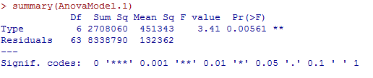

**P-value is less than alpha so we reject the null.**

**We conclude that at least one of the means is different.**

(d) (3 points) Do a pairwise comparison test using the following four methods: : (i) Tukey's HSD, (ii) Scheffe', (iii) Bonferroni, and (iv) Fisher’s LSD. Paste your output and interpret the results for using each of the four methods.

**1= Compact 2=heavy 3=light 4=medium 5=minivan 6=pickup 7=van**

LSD Tukeys

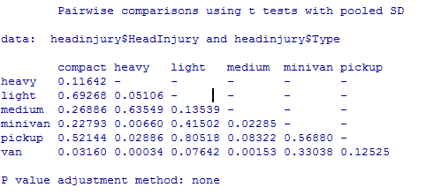 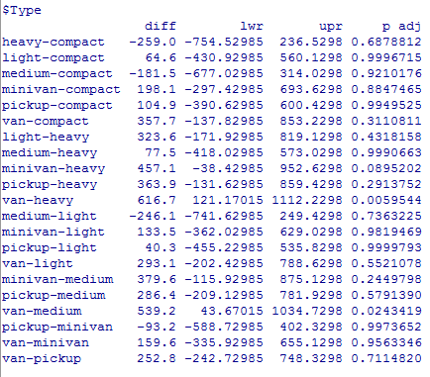

Bonferroni Scheffe

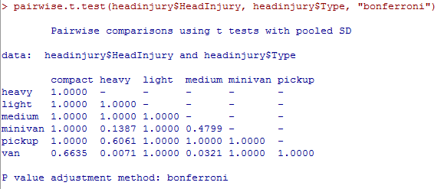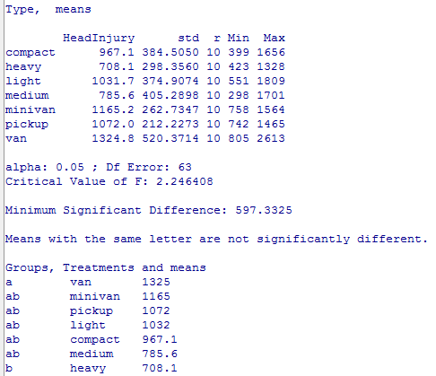

**For Fisher’s LSD, Compact (1) is different than van (7); heavy car (2) is different than minivan (5), pickup (6) and van (7); medium car (4) is different than minivan (5) and van (7) (all of the other differences displayed are redundant)**

**For Tukey’s, heavy car (2) is different than van (7), medium car (4) is different than van (7) (all of the other differences displayed are redundant)**

**For Bonferroni, heavy car (2) is different than van (7), medium car (4) is different than van (7) (all of the other differences displayed are redundant)**

**For Scheffe’s, heavy car (4) is different than van (7) (all of the other differences displayed are redundant)**

**Fisher’s LSD picks up more differences and Scheffe’s picks up fewer.**

3. Out of the four methods: (i) Tukey's HSD, (ii) Scheffe', (iii) Bonferroni, and (iv) Fisher’s LSD, choose the best method given the following scenarios:

(a) (2 points) You would like to do an exploratory analysis to see which means or contrasts are different. **Scheffe’**

(b) (2 points) Based on the structure of the data, you know which contrasts or comparisons you know the 3 comparisons or contrasts that you want to make. **Bonferroni**

(c) (2 points) You are interested in all pairwise comparisons, but you want to keep your family-wise Type I error rate at 0.05. **Tukey’s**

(d) (2 points) You are interested in all pairwise comparisons, but you want the capacity to detect any real differences. **Fisher’s LSD**

**DON’T FORGET TO SCORE YOUR HOMEWORK AT THE TOP**